**Binary Search Tree: Lab09**

1. Given the binary tree diagram below, perform the following traversal methods:

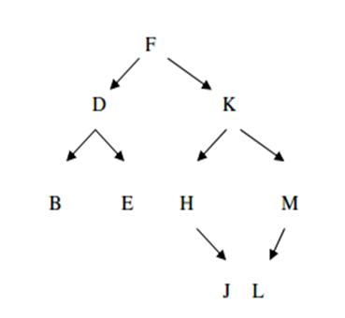

* 1. Inorder

B,D,E,F,H,J,K,L,M

* 1. Preorder

F,D,B,E,K,H,J,M,L

* 1. Postorder

B,E,D,J,H,L,M,K,F

1. Answer the following questions in the context of binary tree.
2. Write C++ statements to declare a structure for a binary search tree's node. The structure tag is node, with left and right pointers left and right, respectively. Each node contains a character, known as key. (4 marks)
3. Draw a diagram to insert the following data (in the order given) into a binary search tree. Assume that the tree is initially empty. (9 marks)

Malaysia, Dominica, Canada, Auckland, California, Bosnia, Africa, Zimbabwe, Doha